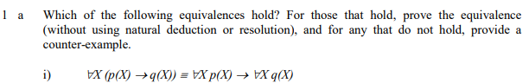







Since both have for-all quantifiers on the outside, it is sufficient to prove for some arbitrary constant *a*

$$p\left(a\right)∧q\left(a\right)→¬r\left(a\right)≡¬\left(p\left(a\right)∧q\left(a\right)\right)∨¬r\left(a\right)≡¬p\left(a\right)∨¬q\left(a\right)∨¬r\left(a\right)≡¬r\left(a\right)∨\left(¬p\left(a\right)∨¬q\left(a\right)\right)≡r\left(a\right)→(p\left(a\right)→¬q\left(a\right))$$

This shows that these statements are not equivalent. An example would be for a instance *a* such that:

$$r\left(a\right),p\left(a\right),¬q(a)$$

Clearly, the first statement then holds:

$$r\left(a\right)→(\left(p\left(a\right)→¬q\left(a\right)\right)≡True→\left(True→True\right)≡True→True≡True$$

And second does not:

$$r\left(a\right)→(\left(p\left(a\right)→q\left(a\right)\right)≡True→\left(True→False\right)≡True→False≡False$$

Hence, two statements are not the same since

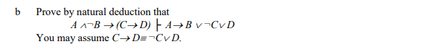

1. ~~given~~
2. ~~assume (DISCHARGED)~~
3. ~~assume (DISCHARGED)~~
4. ~~,2,3~~
5. ~~, 1,4~~
6. ~~given equivalent~~
7. ~~`~~  ~~,3,6~~
8. ~~assume (DISCHARGED)~~
9. ~~,7~~
11. ~~Law of Excluded Middle~~
12. ~~Proof by cases, 7,10,11~~
14. ~~,2,13~~

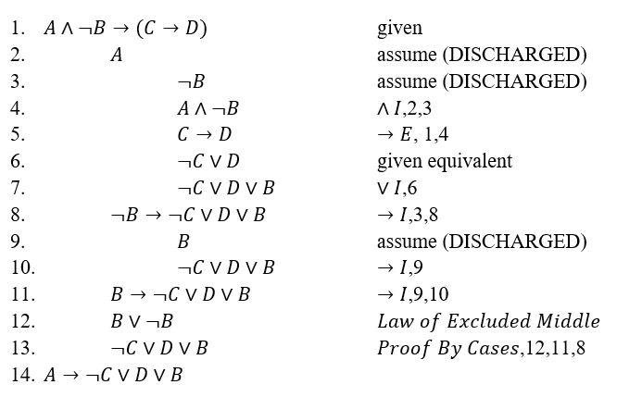

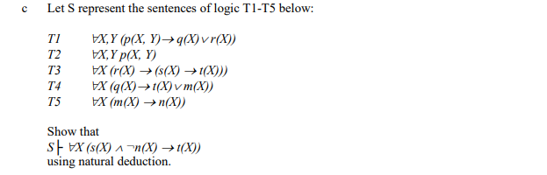

1. given givcen
2. $∀X\left(r\left(X\right)→\left(s\left(X\right)→t\left(X\right)\right)\right)$ given
3. $∀X\left(q\left(X\right)→t\left(X\right)∨m\left(X\right)\right)$ give
4. ∀𝑋(𝑞(𝑋)→𝑡(𝑋)∨𝑚(𝑋))∀XqX→tX∨mX given
5. $s\left(a\right)∧¬n(a)$ assume (DISCHARGED)
6. $p(a,b)$ $∀E$, 2
7. $q\left(a\right)∨r\left(a\right)$ $∀E$, $→E$,1,7
8. $q\left(a\right)$ assume (DISCHARGED)
9. $t\left(a\right)∨m\left(a\right)$ $∀E,→E$,4,9
10. $m(a)$ assume (DISCHARGED)
11. $n(a)$ $∀E,→E$, 4,11
12. $¬n(a)$ $∧E$, 5
13. $¬m(a)$ RAA, 11,12,13 (DISCHARGED)
14. $t\left(a\right)$ $∨E$,10,14
$q\left(a\right)→t\left(a\right)$ $→I,9,15$

16. $r(a)$ assume (DISCHARGED)
17. $s\left(a\right)→t(a)$ $∀E,→E$,3,17
18. $s(a)$ $∧E$,6
19. $t(a)$ $→E,$ 18,19
20. $r\left(a\right)→t\left(a\right)$ $→I$,17,20
21. $t(a)$ proof by cases, 8,16,21
22. $s\left(a\right)∧¬n\left(a\right)→t(a)$ $→I$,6,22
23. $∀X(s\left(X\right)∧¬\left(X\right)→t\left(X\right))$ $∀I$,23

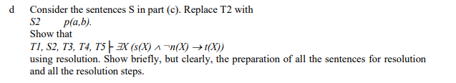

1. Convert all sentences into CNF

T1: $∀X,Y(p\left(X,Y\right)→q\left(X\right)∨r\left(X\right)=∀X,Y(¬p\left(X,Y\right)∨q\left(X\right)∨\left(rX\right))$

S2: $p$ (a,b)

T3: $∀X\left(r\left(X\right)→\left(s\left(X\right)→t\left(X\right)\right)\right)=∀X(¬r\left(X\right)∨¬s\left(X\right)∨t\left(X\right))$

T4: $∀X\left(q\left(X\right)→t\left(X\right)∨m\left(X\right)\right)=∀X(¬q\left(X\right)∨t\left(x\right)∨m\left(x\right))$

T5: $∀X\left(m\left(X\right)→n\left(X\right)\right)=∀X(¬m\left(X\right)∨n\left(X\right))$

1. Rename the variables uniquely and drop universal quantifiers

T1: $∀X1,Y1\left(¬p\left(X1,Y1\right)∨q\left(X1\right)∨\left(rX1\right)\right)=¬p\left(X1,Y1\right)∨q\left(X1\right)∨\left(rX1\right)$

S2: $p(a,b)$

T3: $∀X2\left(¬r\left(X2\right)∨¬s\left(X2\right)∨t\left(X2\right)\right)=¬r\left(X2\right)∨¬s\left(X2\right)∨t\left(X2\right)$

T4: $∀X3\left(¬q\left(X3\right)∨t\left(X3\right)∨m\left(X3\right)\right)=¬q\left(X3\right)∨t\left(X3\right)∨m\left(X3\right)$

T5: $∀X4\left(¬m\left(X4\right)∨n\left(X4\right)\right)=¬m\left(X4\right)∨n\left(X4\right)$

1. Negate the conclusion and convert to CNF
$$¬ \left(∃X\left(s\left(X\right)∧¬n\left(X\right)→t\left(X\right)\right)\right)=∀X(¬\left(s\left(X\right)∧¬n\left(X\right)→t\left(X\right))\right)=$$

$$=∀X\left(¬\left(¬\left(s\left(X\right)∧¬n\left(X\right)\right)∨t\left(X\right)\right)\right)=∀X\left(¬\left(¬s\left(X\right)∨n\left(X\right)∨t\left(X\right)\right)\right)=∀X\left(s\left(X\right)∧¬n\left(X\right)∧¬t\left(X\right)\right)=s\left(X5\right)∧¬n\left(X5\right)∧¬t(X5)$$

2. Derive an inconsistency

|  |  |
| --- | --- |
|  |  |
|  |  |
|  |  |
|  |  |
|  |  |
|  |  |
|  |  |
|  |  |

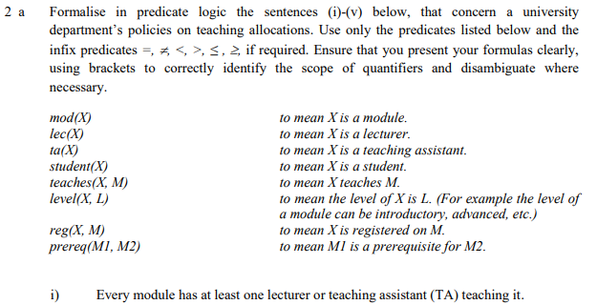



First, formalise: “No lecturer teaches more than one advanced module”:

$$¬∃M1,M2,L\left(level\left(M1,\text{advanced}\right)∧level\left(M2,advanced\right)∧M1≠M2∧lec\left(L\right)∧teaches\left(L,M1\right)∧teaches\left(L,M2\right)\right)$$

Next, formalise: “Some Tas teach more than one module at any one level”:

$$∃T,M1,M2, L\left(mod\left(M1\right)∧mod\left(M2\right)∧M1≠M2∧level\left(M1,L\right)∧level\left(M2,L\right)∧ta\left(T\right)∧teaches\left(T,M1\right)∧teaches\left(T,M2\right)\right)$$

These two sentences must then by connected by a conjunction ().







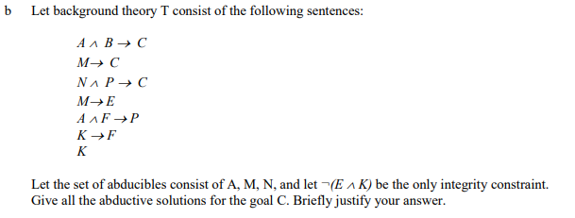

1. Convert all background theory to CNF
$$A∧B→C≡¬\left(A∧B\right)∨C≡¬A∨¬B∨C$$

$$M→C≡¬M∨C$$

$$N∧P→C≡¬N∨¬P∨C$$

$$M→E≡¬M∨E$$

$$A∧F→P≡¬A∨¬F∨P$$

$$K→F≡¬K∨F$$

$$K$$

2. Convert integrity constraint to CNF
$$¬\left(E∧K\right)≡¬E∨¬K$$

3. Negate conclusion and convert to CNF

|  |  |
| --- | --- |
|  |  |
|  |  |
|  |  |

|  |  |
| --- | --- |
|  |  |
|  |  |
|  |  |
|  |  |
|  |  |
|  |  |

Need to check integrity constraints here.

M -> E, and since K is in T, the first solution does not work.